**SPARK CLUSTER ASSIGNMENT**

**Name: S.Nikhil Sai**

**Date: 18-11-2024**

**1. Spark RDD:**

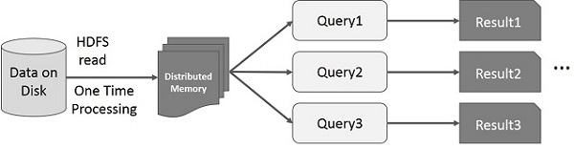

**Expalnation:**

The image specifically illustrates Apache Spark's RDD (Resilient Distributed Dataset) architecture and its key characteristics. It illustrates the architecture of a distributed data processing system, specifically showing how data flows from storage to results through distributed processing.

**Breakdown:**

* "Data on Disk" represents the raw data storage (shown as a cylinder symbol typically used for databases/storage)
* "HDFS read" indicates the data is being read from a Hadoop Distributed File System (HDFS)
* "One Time Processing" suggests this is a batch processing operation
* The data moves into "Distributed Memory" (shown as a darker rectangular block)
* This represents data being loaded into memory across multiple nodes in a distributed system
* Multiple queries (Query1, Query2, Query3) can be executed in parallel against the same distributed dataset
* Each query produces its own result (Result1, Result2, Result3)

**Process:**

* Data is loaded once from persistent storage
* The loaded data is distributed across multiple nodes' memory
* Multiple queries/transformations can be performed on the same dataset without reloading from disk
* This approach optimizes performance by minimizing I/O operations and enabling parallel processing.

**2. Creating the cluster in Data bricks:**

**Step 1:** After the successful creation of data bricks account, click on ‘compute’ on the left side bar.

**Step 2:** After getting into compute section, click on create compute option that appears on right top.

**Step 3:** Now, name the cluster and give appropriate details to create a new cluster**.** And click on create compute option that appears on bottom left.

**Step 4:** The cluster might take a couple of minutes to get created. Once the cluster is created, click on the compute option that appears on left sidebar to view the newly created cluster.

Thus, the cluster is created:

